# Test Design Techniques

# Homework

## Valid vs. Invalid Values

* Imagine you are a security guard at the airport. You have to define whether the hand luggage is allowed or not. Sort out the valid and invalid content or characteristic of the luggage by following the British Airline restrictions. Extra baggage is not allowed.

*You could check this [url](http://www.britishairways.com/en-gb/information/baggage-essentials/hand-baggage-allowances) for extra information about the restrictions. Check out the Packing restrictions at the bottom of the page.

VALID

INVALID

Wet wipes

Small scissors

Cough syrup 120ml

24kg bag

Umbrela

23*40*25 sized cabin bag

150 ml Perfume

23*30*25 sized personal bag

Thermometer with mercury

Laptop

Pepper spray

Tennis racket

## Test Design Techniques

* Below is the diagram of test design techniques – fill in the names of the different techniques and

match them with a sentence form the box to the left. (See the example)

**Testing**

**(2)**

**(7)**

**(5)**

**(6)**

**(8)**

**(9)**

**(3)**

**(4)**

**(1)**

**(11)**

**(10)**

1. Tests are based on people's skills, knowledge, intuition and experience
2. One of the types is Walkthrough
3. Also called specification-based
4. Structure-based techniques
5. Involve running (executing)
6. Analyzing software “at rest”
7. Tests are derived systematically from what is known about the defect
8. What the system does?
9. Examining running software to see how it behaves under different stimuli
10. How the system does what it does?
11. Do not involve running (executing)
12. Static - k
13. Dynamic - e
14. Review - b
15. Static Analysis -f
16. Black-box -c
17. White-box -d
18. Experience-based -a
19. Experience-based -g
20. Dynamic analysis -i
21. Functional -h
22. Non-Functional -j

* **1. Static - k**
* **2. Dynamic**
* **3.___________**
* **4.___________**
* **5.___________**
* **6.___________**
* **7.___________**
* **8.___________**
* **9.___________**
* **10.__________**
* **11.__________**
* **1. Static - k**
* **2. Dynamic**
* **3.___________**
* **4.___________**
* **5.___________**
* **6.___________**
* **7.___________**
* **8.___________**
* **9.___________**
* **10.__________**
* **11.__________**
* **1. Static - k**
* **2. Dynamic**
* **3.___________**
* **4.___________**
* **5.___________**
* **6.___________**
* **7.___________**
* **8.___________**
* **9.___________**
* **10.__________**
* **11.__________**

\

## Boundary Value Analysis, Equivalence Partitioning & Use Case

* Go to <http://demos.telerik.com/aspnet-ajax/imageeditor/examples/imageupload/defaultcs.aspx?product=asyncupload>

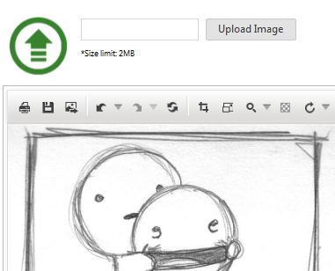

|  |
| --- |
| Upload an image between 0.1 – 2 MB |
| Upload an image more than 2 MB |
| Upload an empty image |
| Upload a file with invalid extention (i.e. .txt, .docx) between 0.1 – 2 MB |
| Upload a file with invalid extention (i.e. .txt, .docx, .avi), changed to valid extention (i.e. to (.jpeg, .png, .gif, .bmp) between 0.1 – 2 MB |

* Go to <http://demos.telerik.com/aspnet-ajax/input/examples/common/datagrid/defaultcs.aspx>
* 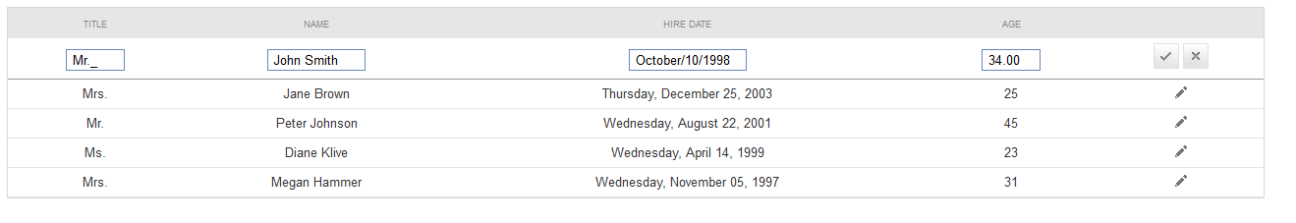

|  |
| --- |
| Submit a record with valid data |
| Submit a record with valid data and invalid Age ( -1, 0, 150) |
| Submit a record with valid data and Hire Date in future |
| Submit a record with valid data and Name with symbols in different alphabets (i.e. Latin, Cyrillic, Arabic) |
| Submit a record with valid data and Name with length 1, 100, 100 000 and more |
| Submit a record with valid data and Name with numbers |
| Submit a record with valid data and invalid Title (i.e. number) |
| Submit a record with a null field |

1. Think of appropriate test cases to test the controls and write them down in a table
2. If you find any bugs, please feel free to report them in a MS Word document

* Download the project MonopolyGame.zip. Run the project following this steps:

1. Unzip the project
2. Run the solution
3. Run the Web Application *//CTRL+F5* ☺

Navigating through the tabs you will find your tasks. Make an archive with your solutions.